
METHOD 51 DESICCANT & HUMIDITY INDICATOR WORKSHEET
*
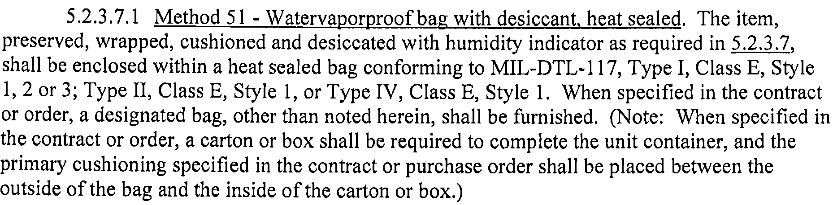
Formula I – To find units of desiccant for use within a sealed container other than rigid all metal.
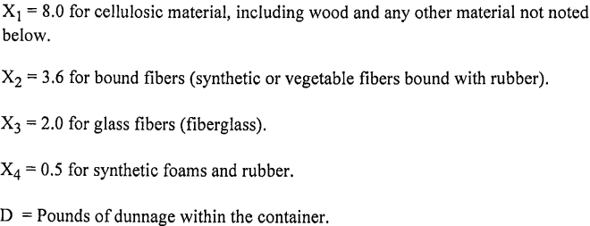
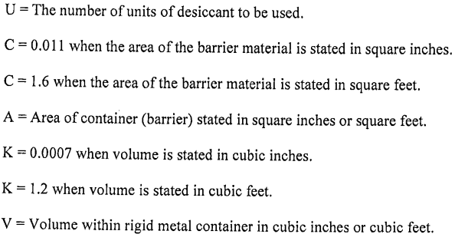
U = CA + X₁D + X₂D + X₃D + X₄D

A= |  | sq/in | X₁= |  | if applicable | X₃ = |  | if applicable
C= |  | sq/in | X₂= |  | if applicable | X₄ = |  | if applicable | D= |  | lbs.

* Method 51 requires desiccant & humidity indicator to be enclosed within the heat sealed bag. Always refer to the contract’s applicable MIL-STD-2073 for approved information.
Use this area for calculation
C A X1 D (.011 x ) + ( x )
CA X1D ( ) + ( ) =

Total number of desiccant units to be added inside each barrier bag for this shipment: U=
DON’T FORGET TO INCLUDE HUMIDITY INDICATOR(S)
Shipper #: Name: Signature: Date:

